**Project 1: Deploying a web server in Windows instance**

**Task 1:** Create a windows instance using AMI

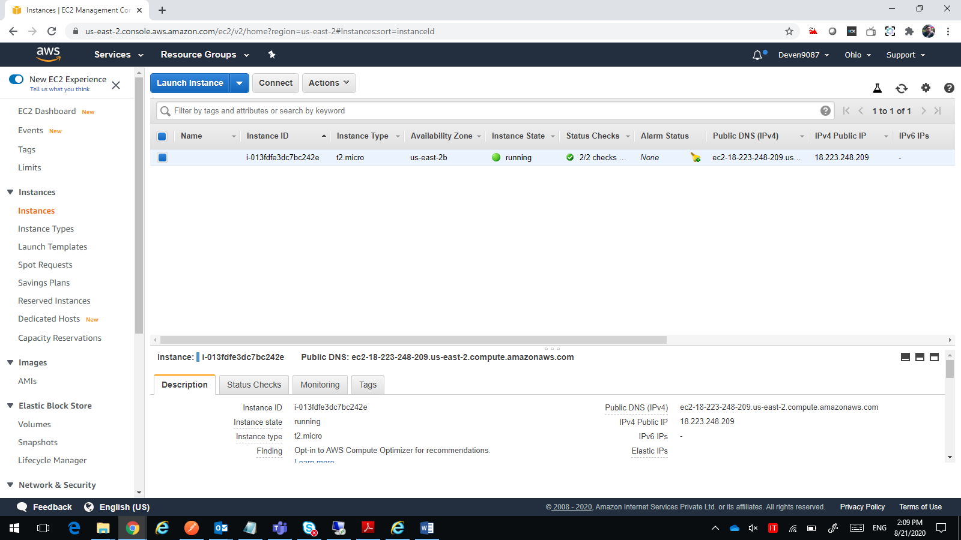

**Task 2:** Launch the Windows instance using RDP

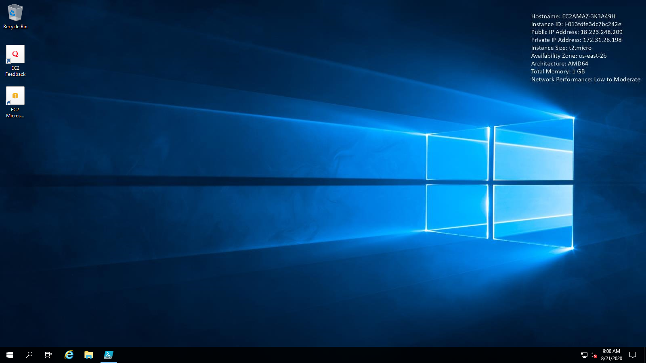

**Task 3:** Install IIS web server using Powershell ISE

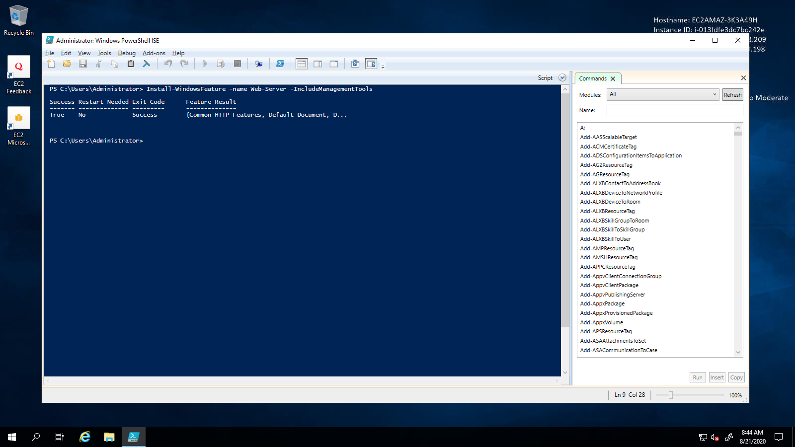

**Task 4:** Verify successful installation of IIS Web Server

